**Web Form**

**Cấu trúc chuẩn cùa Web Design**

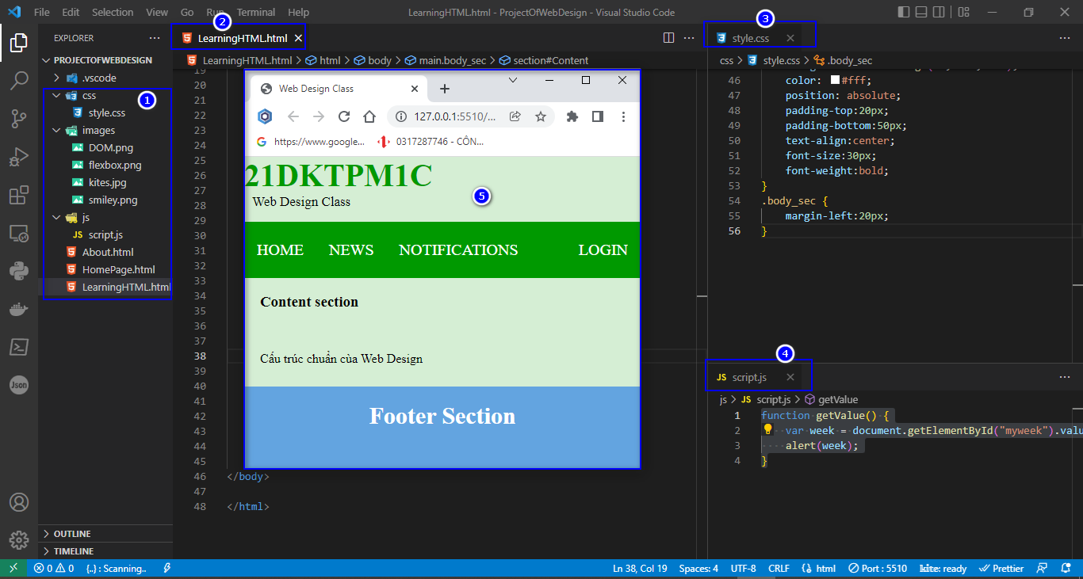

**File.html**

<!DOCTYPE html>

<html lang="en">

<head>

    <meta charset="UTF-8">

    <meta http-equiv="X-UA-Compatible" content="IE=edge">

    <meta name="viewport" content="width=device-width, initial-scale=1.0">

    <title>Web Design Class</title>

    <link rel="stylesheet" type="text/css" href="./css/style.css">

</head>

<body>

     <!-- Header Section -->

     <header>

        <div class="head1">21DKTPM1C</div>

        <div class="head2">Web Design Class</div>

    </header>

    <!-- Menu Navigation Bar -->

    <nav class="menu">

        <a href="#home">HOME</a>

        <a href="#news">NEWS</a>

        <a href="#notification">NOTIFICATIONS</a>

        <div class="menu-log">

            <a href="#login">LOGIN</a>

        </div>

      </nav>

    <!-- Body section -->

    <main class = "body_sec">

        <section id="Content">

            <h3>Content section</h3>

            <br/>

            <p>Cấu trúc chuẩn cùa Web Design</p>

        </section>

      </main>

    <!-- Footer Section -->

    <footer>Footer Section</footer>

    <!--Javascript uses External File-->

    <script type="text/javascript" src="./js/script.js"></script>

</body>

</html>

**File.css**

body {

    background-color: #d5eed4;

}

.head1 {

    font-size:40px;

    color:#009900;

    font-weight:bold;

}

.head2 {

    font-size:17px;

    margin-left:10px;

    margin-bottom:15px;

}

body {

    margin: 0 auto;

    background-position:center;

    background-size: contain;

}

.menu {

    position: sticky;

    top: 0;

    background-color: #009900;

    padding:10px 0px 10px 0px;

    color:white;

    margin: 0 auto;

    overflow: hidden;

}

.menu a {

    float: left;

    color: white;

    text-align: center;

    padding: 14px 16px;

    text-decoration: none;

    font-size: 20px;

}

.menu-log {

    right: auto;

    float: right;

}

footer {

    width: 100%;

    bottom: 0px;

    background-color: rgb(99, 164, 224);

    color: #fff;

    position: absolute;

    padding-top:20px;

    padding-bottom:50px;

    text-align:center;

    font-size:30px;

    font-weight:bold;

}

.body_sec {

    margin-left:20px;

}

**File.js**

function getValue() {

    var week = document.getElementById("myweek").value;

    alert(week);

}

1. **HTML Form:** là các loại hình cho phép người dùng nhập dữ liệu với nhiều cách thức khác nhau.

* Ví dụ: người dùng nhập name, email address, phone numbers, …
* Sử dụng **<form> tag** để tạo nên **HTML form**
* Minh họa

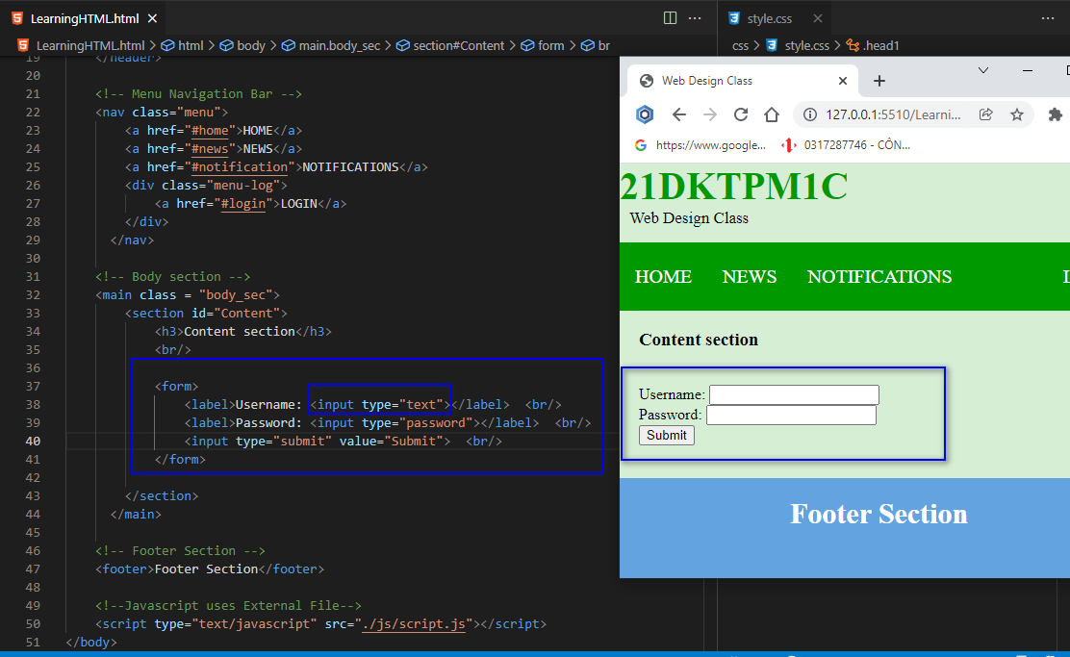

Code mẫu File.html

<!DOCTYPE html>

<html lang="en">

<head>

    <meta charset="UTF-8">

    <meta http-equiv="X-UA-Compatible" content="IE=edge">

    <meta name="viewport" content="width=device-width, initial-scale=1.0">

    <title>Web Design Class</title>

    <link rel="stylesheet" type="text/css" href="./css/style.css">

</head>

<body>

     <!-- Header Section -->

     <header>

        <div class="head1">21DKTPM1C</div>

        <div class="head2">Web Design Class</div>

    </header>

    <!-- Menu Navigation Bar -->

    <nav class="menu">

        <a href="#home">HOME</a>

        <a href="#news">NEWS</a>

        <a href="#notification">NOTIFICATIONS</a>

        <div class="menu-log">

            <a href="#login">LOGIN</a>

        </div>

      </nav>

    <!-- Body section -->

    <main class = "body_sec">

        <section id="Content">

            <h3>Content section</h3>

            <br/>

            <form>

                <label>Username: <input type="text"></label>  <br/>

                <label>Password: <input type="password"></label>  <br/>

                <input type="submit" value="Submit">  <br/>

            </form>

        </section>

      </main>

    <!-- Footer Section -->

    <footer>Footer Section</footer>

    <!--Javascript uses External File-->

    <script type="text/javascript" src="./js/script.js"></script>

</body>

</html>

File.css

body {

    background-color: #d5eed4;

}

.head1 {

    font-size:40px;

    color:#009900;

    font-weight:bold;

}

.head2 {

    font-size:17px;

    margin-left:10px;

    margin-bottom:15px;

}

body {

    margin: 0 auto;

    background-position:center;

    background-size: contain;

}

.menu {

    position: sticky;

    top: 0;

    background-color: #009900;

    padding:10px 0px 10px 0px;

    color:white;

    margin: 0 auto;

    overflow: hidden;

}

.menu a {

    float: left;

    color: white;

    text-align: center;

    padding: 14px 16px;

    text-decoration: none;

    font-size: 20px;

}

.menu-log {

    right: auto;

    float: right;

}

footer {

    width: 100%;

    bottom: 0px;

    background-color: rgb(99, 164, 224);

    color: #fff;

    position: absolute;

    padding-top:20px;

    padding-bottom:50px;

    text-align:center;

    font-size:30px;

    font-weight:bold;

}

.body_sec {

    margin-left:20px;

}

1. Input Element bởi **<input type=”…”** : các input type hay dùng là text field, password field, checkbox, radio button, submit button, reset button, file select box, …



1. Input Element mới trong HTML 5:

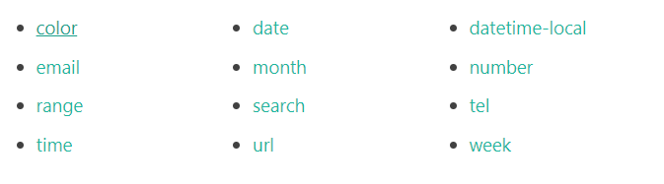

Minh họa

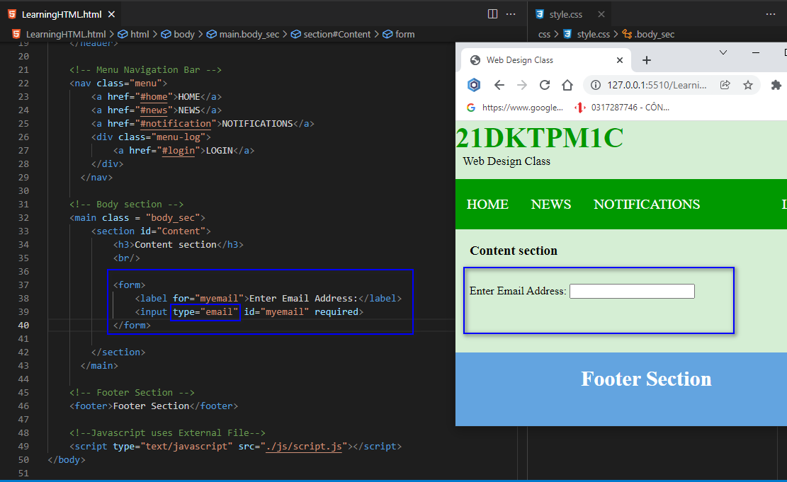

* File.html mẫu

<!DOCTYPE html>

<html lang="en">

<head>

    <meta charset="UTF-8">

    <meta http-equiv="X-UA-Compatible" content="IE=edge">

    <meta name="viewport" content="width=device-width, initial-scale=1.0">

    <title>Web Design Class</title>

    <link rel="stylesheet" type="text/css" href="./css/style.css">

</head>

<body>

     <!-- Header Section -->

     <header>

        <div class="head1">21DKTPM1C</div>

        <div class="head2">Web Design Class</div>

    </header>

    <!-- Menu Navigation Bar -->

    <nav class="menu">

        <a href="#home">HOME</a>

        <a href="#news">NEWS</a>

        <a href="#notification">NOTIFICATIONS</a>

        <div class="menu-log">

            <a href="#login">LOGIN</a>

        </div>

      </nav>

    <!-- Body section -->

    <main class = "body_sec">

        <section id="Content">

            <h3>Content section</h3>

            <br/>

            <form>

                <label for="myemail">Enter Email Address:</label>

                <input type="email" id="myemail" required>

            </form>

        </section>

      </main>

    <!-- Footer Section -->

    <footer>Footer Section</footer>

    <!--Javascript uses External File-->

    <script type="text/javascript" src="./js/script.js"></script>

</body>

</html>

* Minh họa nhập tháng

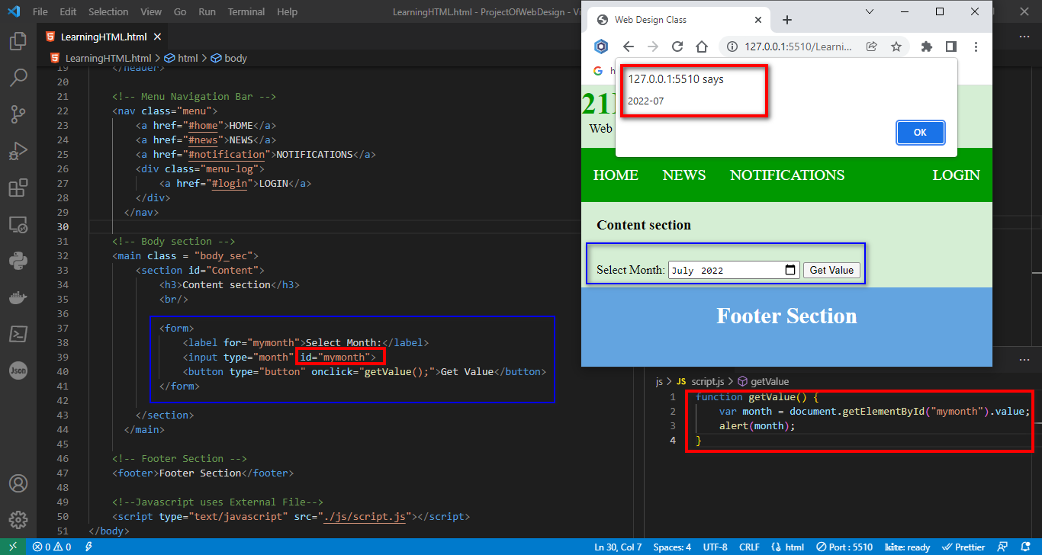

File.html

<!DOCTYPE html>

<html lang="en">

<head>

    <meta charset="UTF-8">

    <meta http-equiv="X-UA-Compatible" content="IE=edge">

    <meta name="viewport" content="width=device-width, initial-scale=1.0">

    <title>Web Design Class</title>

    <link rel="stylesheet" type="text/css" href="./css/style.css">

</head>

<body>

     <!-- Header Section -->

     <header>

        <div class="head1">21DKTPM1C</div>

        <div class="head2">Web Design Class</div>

    </header>

    <!-- Menu Navigation Bar -->

    <nav class="menu">

        <a href="#home">HOME</a>

        <a href="#news">NEWS</a>

        <a href="#notification">NOTIFICATIONS</a>

        <div class="menu-log">

            <a href="#login">LOGIN</a>

        </div>

      </nav>

    <!-- Body section -->

    <main class = "body_sec">

        <section id="Content">

            <h3>Content section</h3>

            <br/>

            <form>

                <label for="mymonth">Select Month:</label>

                <input type="month" id="mymonth">

                <button type="button" onclick="getValue();">Get Value</button>

            </form>

        </section>

      </main>

    <!-- Footer Section -->

    <footer>Footer Section</footer>

    <!--Javascript uses External File-->

    <script type="text/javascript" src="./js/script.js"></script>

</body>

</html>

File**.js**

function getValue() {

    var month = document.getElementById("mymonth").value;

    alert(month);

}

1. Input Type Color

Minh họa

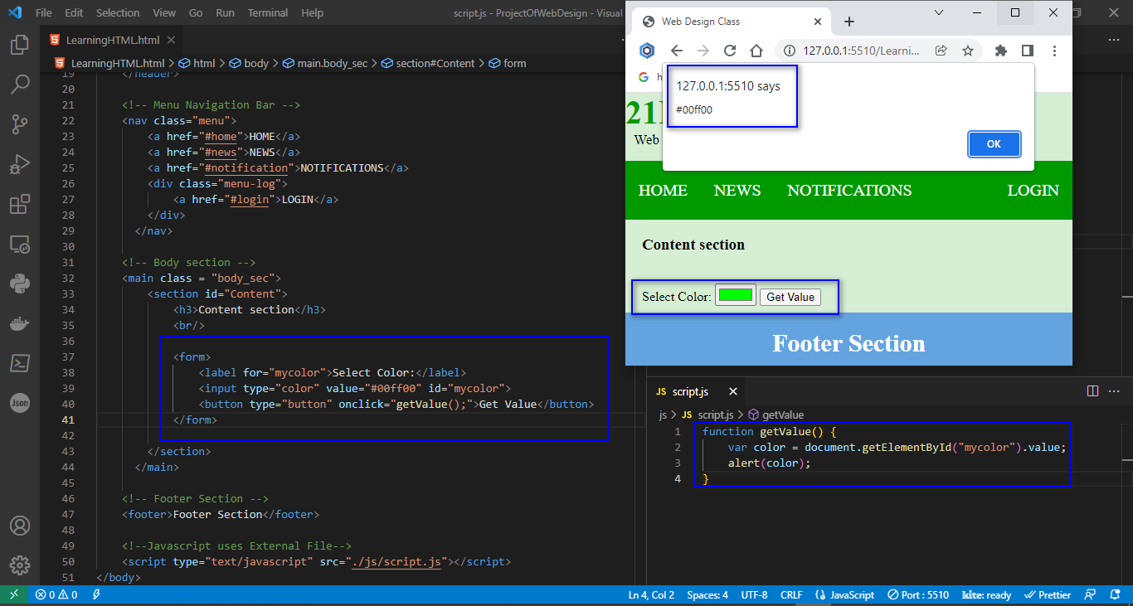

File.html

<!DOCTYPE html>

<html lang="en">

<head>

    <meta charset="UTF-8">

    <meta http-equiv="X-UA-Compatible" content="IE=edge">

    <meta name="viewport" content="width=device-width, initial-scale=1.0">

    <title>Web Design Class</title>

    <link rel="stylesheet" type="text/css" href="./css/style.css">

</head>

<body>

     <!-- Header Section -->

     <header>

        <div class="head1">21DKTPM1C</div>

        <div class="head2">Web Design Class</div>

    </header>

    <!-- Menu Navigation Bar -->

    <nav class="menu">

        <a href="#home">HOME</a>

        <a href="#news">NEWS</a>

        <a href="#notification">NOTIFICATIONS</a>

        <div class="menu-log">

            <a href="#login">LOGIN</a>

        </div>

      </nav>

    <!-- Body section -->

    <main class = "body_sec">

        <section id="Content">

            <h3>Content section</h3>

            <br/>

            <form>

                <label for="mycolor">Select Color:</label>

                <input type="color" value="#00ff00" id="mycolor">

                <button type="button" onclick="getValue();">Get Value</button>

            </form>

        </section>

      </main>

    <!-- Footer Section -->

    <footer>Footer Section</footer>

    <!--Javascript uses External File-->

    <script type="text/javascript" src="./js/script.js"></script>

</body>

</html>

File.js

function getValue() {

    var color = document.getElementById("mycolor").value;

    alert(color);

}

1. Input Type Date

Minh họa

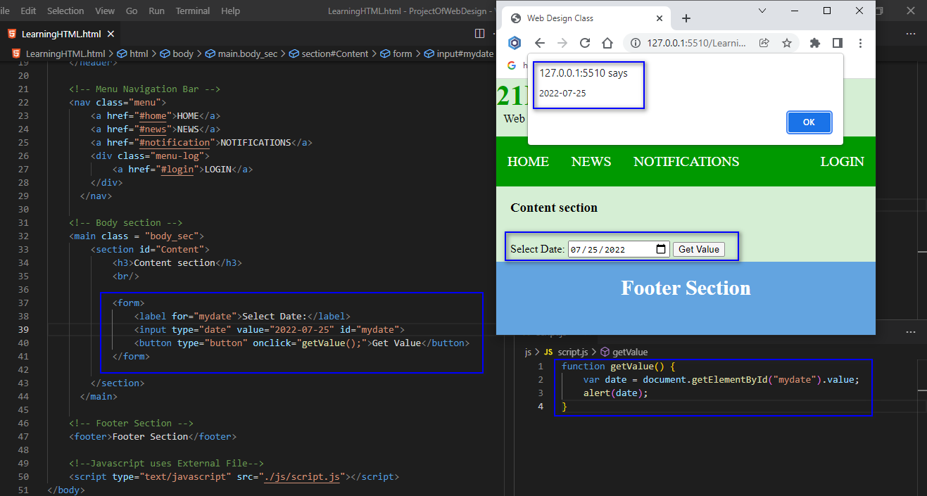

File.html

<!DOCTYPE html>

<html lang="en">

<head>

    <meta charset="UTF-8">

    <meta http-equiv="X-UA-Compatible" content="IE=edge">

    <meta name="viewport" content="width=device-width, initial-scale=1.0">

    <title>Web Design Class</title>

    <link rel="stylesheet" type="text/css" href="./css/style.css">

</head>

<body>

     <!-- Header Section -->

     <header>

        <div class="head1">21DKTPM1C</div>

        <div class="head2">Web Design Class</div>

    </header>

    <!-- Menu Navigation Bar -->

    <nav class="menu">

        <a href="#home">HOME</a>

        <a href="#news">NEWS</a>

        <a href="#notification">NOTIFICATIONS</a>

        <div class="menu-log">

            <a href="#login">LOGIN</a>

        </div>

      </nav>

    <!-- Body section -->

    <main class = "body_sec">

        <section id="Content">

            <h3>Content section</h3>

            <br/>

            <form>

                <label for="mydate">Select Date:</label>

                <input type="date" value="2022-07-25" id="mydate">

                <button type="button" onclick="getValue();">Get Value</button>

            </form>

        </section>

      </main>

    <!-- Footer Section -->

    <footer>Footer Section</footer>

    <!--Javascript uses External File-->

    <script type="text/javascript" src="./js/script.js"></script>

</body>

</html>

File.js

function getValue() {

    var date = document.getElementById("mydate").value;

    alert(date);

}

1. Input Type Datetime-local

Minh họa

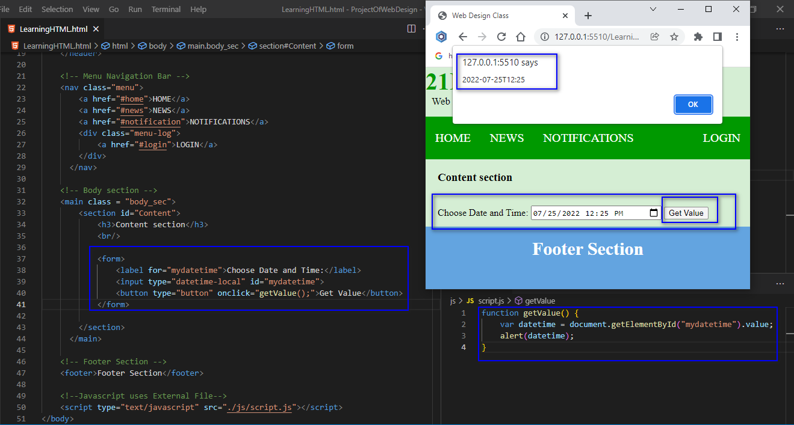

File.html

<!DOCTYPE html>

<html lang="en">

<head>

    <meta charset="UTF-8">

    <meta http-equiv="X-UA-Compatible" content="IE=edge">

    <meta name="viewport" content="width=device-width, initial-scale=1.0">

    <title>Web Design Class</title>

    <link rel="stylesheet" type="text/css" href="./css/style.css">

</head>

<body>

     <!-- Header Section -->

     <header>

        <div class="head1">21DKTPM1C</div>

        <div class="head2">Web Design Class</div>

    </header>

    <!-- Menu Navigation Bar -->

    <nav class="menu">

        <a href="#home">HOME</a>

        <a href="#news">NEWS</a>

        <a href="#notification">NOTIFICATIONS</a>

        <div class="menu-log">

            <a href="#login">LOGIN</a>

        </div>

      </nav>

    <!-- Body section -->

    <main class = "body_sec">

        <section id="Content">

            <h3>Content section</h3>

            <br/>

            <form>

                <label for="mydatetime">Choose Date and Time:</label>

                <input type="datetime-local" id="mydatetime">

                <button type="button" onclick="getValue();">Get Value</button>

            </form>

        </section>

      </main>

    <!-- Footer Section -->

    <footer>Footer Section</footer>

    <!--Javascript uses External File-->

    <script type="text/javascript" src="./js/script.js"></script>

</body>

</html>

File.css

function getValue() {

    var datetime = document.getElementById("mydatetime").value;

    alert(datetime);

}

1. Input Type Email

Minh họa

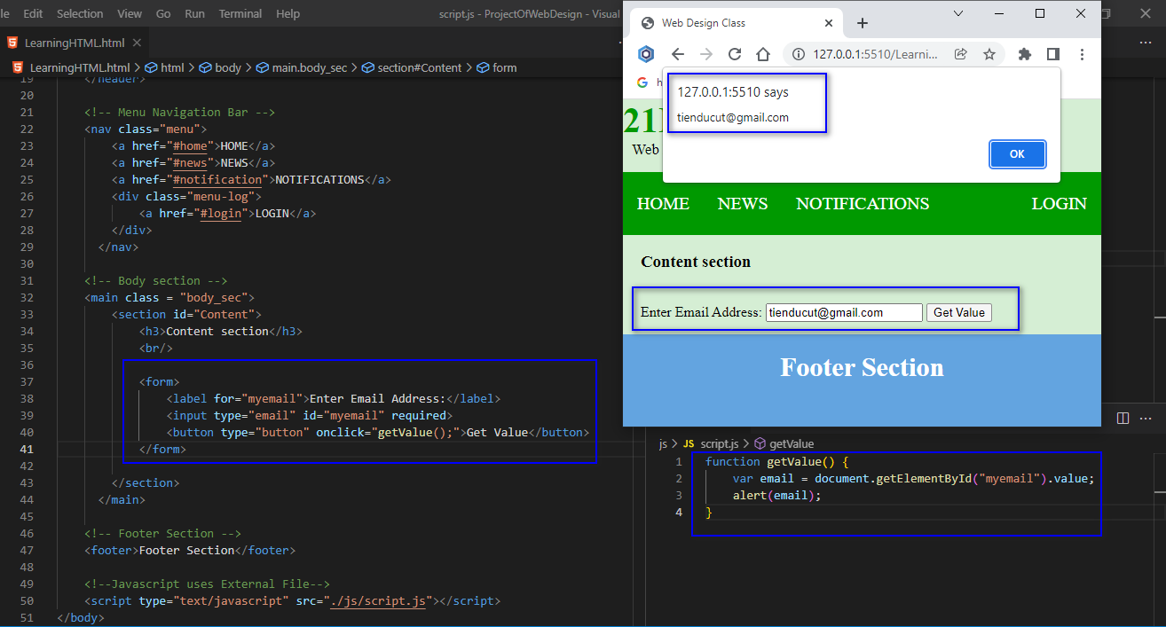

File.html

<!DOCTYPE html>

<html lang="en">

<head>

    <meta charset="UTF-8">

    <meta http-equiv="X-UA-Compatible" content="IE=edge">

    <meta name="viewport" content="width=device-width, initial-scale=1.0">

    <title>Web Design Class</title>

    <link rel="stylesheet" type="text/css" href="./css/style.css">

</head>

<body>

     <!-- Header Section -->

     <header>

        <div class="head1">21DKTPM1C</div>

        <div class="head2">Web Design Class</div>

    </header>

    <!-- Menu Navigation Bar -->

    <nav class="menu">

        <a href="#home">HOME</a>

        <a href="#news">NEWS</a>

        <a href="#notification">NOTIFICATIONS</a>

        <div class="menu-log">

            <a href="#login">LOGIN</a>

        </div>

      </nav>

    <!-- Body section -->

    <main class = "body_sec">

        <section id="Content">

            <h3>Content section</h3>

            <br/>

            <form>

                <label for="myemail">Enter Email Address:</label>

                <input type="email" id="myemail" required>

                <button type="button" onclick="getValue();">Get Value</button>

            </form>

        </section>

      </main>

    <!-- Footer Section -->

    <footer>Footer Section</footer>

    <!--Javascript uses External File-->

    <script type="text/javascript" src="./js/script.js"></script>

</body>

</html>

File.js

function getValue() {

    var email = document.getElementById("myemail").value;

    alert(email);

}

1. Input Type Number

Minh họa

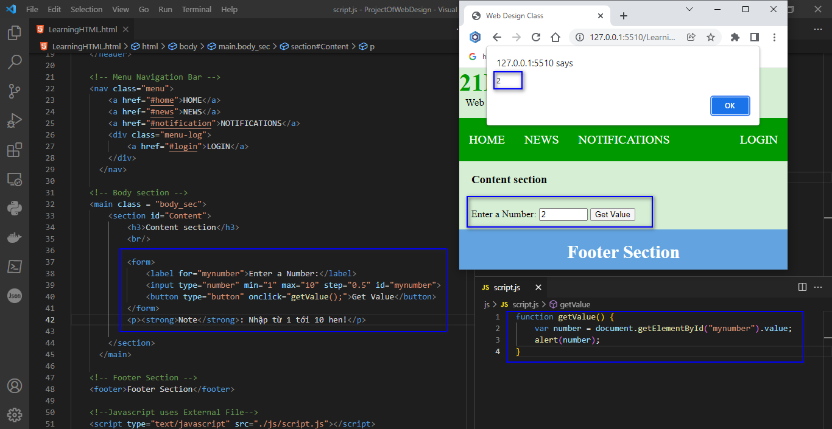

File.html

<!DOCTYPE html>

<html lang="en">

<head>

    <meta charset="UTF-8">

    <meta http-equiv="X-UA-Compatible" content="IE=edge">

    <meta name="viewport" content="width=device-width, initial-scale=1.0">

    <title>Web Design Class</title>

    <link rel="stylesheet" type="text/css" href="./css/style.css">

</head>

<body>

     <!-- Header Section -->

     <header>

        <div class="head1">21DKTPM1C</div>

        <div class="head2">Web Design Class</div>

    </header>

    <!-- Menu Navigation Bar -->

    <nav class="menu">

        <a href="#home">HOME</a>

        <a href="#news">NEWS</a>

        <a href="#notification">NOTIFICATIONS</a>

        <div class="menu-log">

            <a href="#login">LOGIN</a>

        </div>

      </nav>

    <!-- Body section -->

    <main class = "body_sec">

        <section id="Content">

            <h3>Content section</h3>

            <br/>

            <form>

                <label for="mynumber">Enter a Number:</label>

                <input type="number" min="1" max="10" step="0.5" id="mynumber">

                <button type="button" onclick="getValue();">Get Value</button>

            </form>

            <p><strong>Note</strong>: Nhập từ 1 tới 10 hen!</p>

        </section>

      </main>

    <!-- Footer Section -->

    <footer>Footer Section</footer>

    <!--Javascript uses External File-->

    <script type="text/javascript" src="./js/script.js"></script>

</body>

</html>

File.js

function getValue() {

    var number = document.getElementById("mynumber").value;

    alert(number);

}

1. Input Type Range

Minh họa

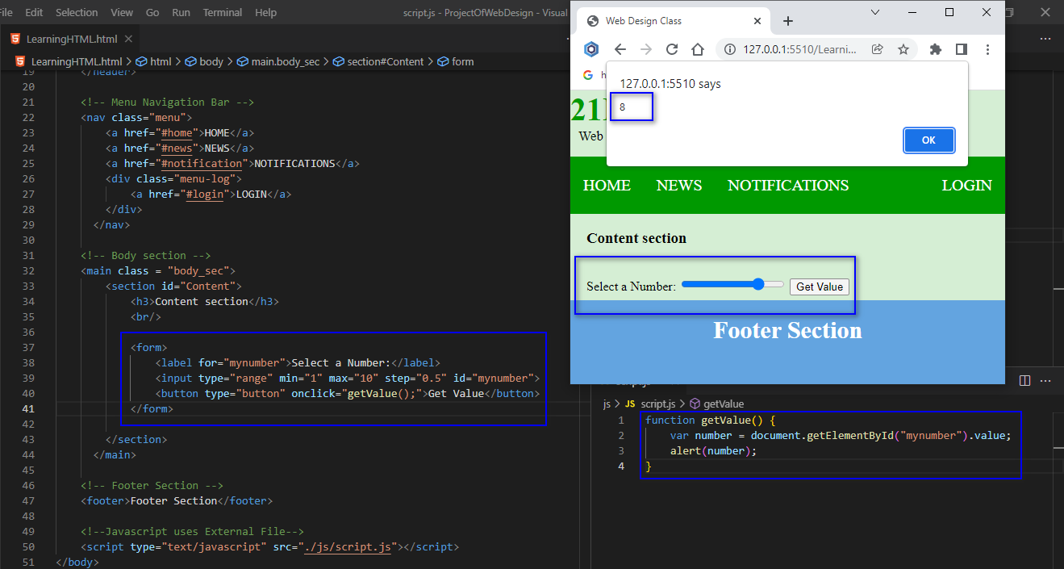

File.html

<!DOCTYPE html>

<html lang="en">

<head>

    <meta charset="UTF-8">

    <meta http-equiv="X-UA-Compatible" content="IE=edge">

    <meta name="viewport" content="width=device-width, initial-scale=1.0">

    <title>Web Design Class</title>

    <link rel="stylesheet" type="text/css" href="./css/style.css">

</head>

<body>

     <!-- Header Section -->

     <header>

        <div class="head1">21DKTPM1C</div>

        <div class="head2">Web Design Class</div>

    </header>

    <!-- Menu Navigation Bar -->

    <nav class="menu">

        <a href="#home">HOME</a>

        <a href="#news">NEWS</a>

        <a href="#notification">NOTIFICATIONS</a>

        <div class="menu-log">

            <a href="#login">LOGIN</a>

        </div>

      </nav>

    <!-- Body section -->

    <main class = "body_sec">

        <section id="Content">

            <h3>Content section</h3>

            <br/>

            <form>

                <label for="mynumber">Select a Number:</label>

                <input type="range" min="1" max="10" step="0.5" id="mynumber">

                <button type="button" onclick="getValue();">Get Value</button>

            </form>

        </section>

      </main>

    <!-- Footer Section -->

    <footer>Footer Section</footer>

    <!--Javascript uses External File-->

    <script type="text/javascript" src="./js/script.js"></script>

</body>

</html>

File.js

function getValue() {

    var number = document.getElementById("mynumber").value;

    alert(number);

}

1. Input Type Search

Minh họa

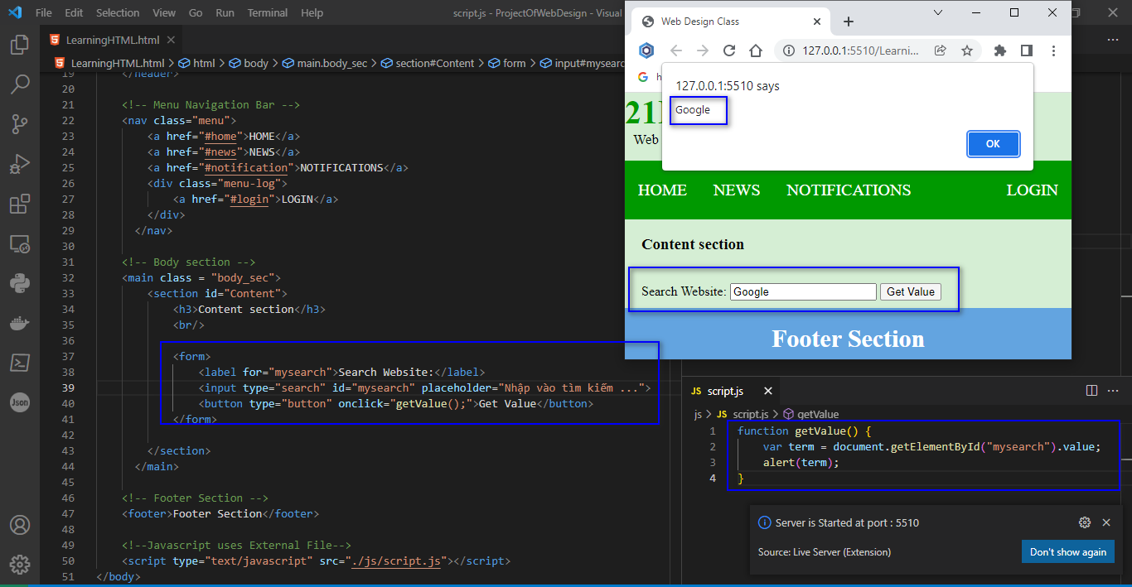

File.html

<!DOCTYPE html>

<html lang="en">

<head>

    <meta charset="UTF-8">

    <meta http-equiv="X-UA-Compatible" content="IE=edge">

    <meta name="viewport" content="width=device-width, initial-scale=1.0">

    <title>Web Design Class</title>

    <link rel="stylesheet" type="text/css" href="./css/style.css">

</head>

<body>

     <!-- Header Section -->

     <header>

        <div class="head1">21DKTPM1C</div>

        <div class="head2">Web Design Class</div>

    </header>

    <!-- Menu Navigation Bar -->

    <nav class="menu">

        <a href="#home">HOME</a>

        <a href="#news">NEWS</a>

        <a href="#notification">NOTIFICATIONS</a>

        <div class="menu-log">

            <a href="#login">LOGIN</a>

        </div>

      </nav>

    <!-- Body section -->

    <main class = "body_sec">

        <section id="Content">

            <h3>Content section</h3>

            <br/>

            <form>

                <label for="mysearch">Search Website:</label>

                <input type="search" id="mysearch" placeholder="Nhập vào tìm kiếm ...">

                <button type="button" onclick="getValue();">Get Value</button>

            </form>

        </section>

      </main>

    <!-- Footer Section -->

    <footer>Footer Section</footer>

    <!--Javascript uses External File-->

    <script type="text/javascript" src="./js/script.js"></script>

</body>

</html>

File.js

function getValue() {

    var term = document.getElementById("mysearch").value;

    alert(term);

}

1. Input Type Tel

Minh họa

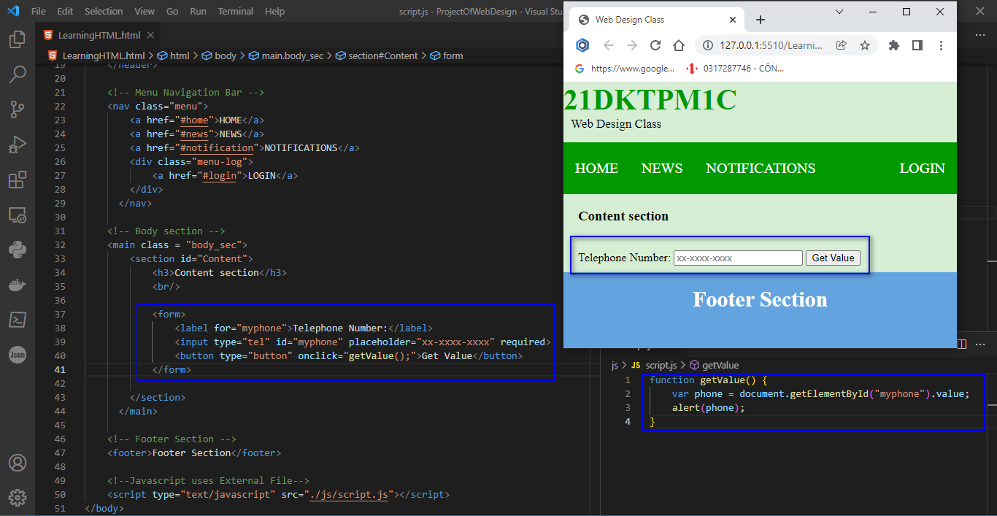

File.html

<!DOCTYPE html>

<html lang="en">

<head>

    <meta charset="UTF-8">

    <meta http-equiv="X-UA-Compatible" content="IE=edge">

    <meta name="viewport" content="width=device-width, initial-scale=1.0">

    <title>Web Design Class</title>

    <link rel="stylesheet" type="text/css" href="./css/style.css">

</head>

<body>

     <!-- Header Section -->

     <header>

        <div class="head1">21DKTPM1C</div>

        <div class="head2">Web Design Class</div>

    </header>

    <!-- Menu Navigation Bar -->

    <nav class="menu">

        <a href="#home">HOME</a>

        <a href="#news">NEWS</a>

        <a href="#notification">NOTIFICATIONS</a>

        <div class="menu-log">

            <a href="#login">LOGIN</a>

        </div>

      </nav>

    <!-- Body section -->

    <main class = "body_sec">

        <section id="Content">

            <h3>Content section</h3>

            <br/>

            <form>

                <label for="myphone">Telephone Number:</label>

                <input type="tel" id="myphone" placeholder="xx-xxxx-xxxx" required>

                <button type="button" onclick="getValue();">Get Value</button>

            </form>

        </section>

      </main>

    <!-- Footer Section -->

    <footer>Footer Section</footer>

    <!--Javascript uses External File-->

    <script type="text/javascript" src="./js/script.js"></script>

</body>

</html>

File.js

function getValue() {

    var phone = document.getElementById("myphone").value;

    alert(phone);

}

1. Input Type Time

Minh họa

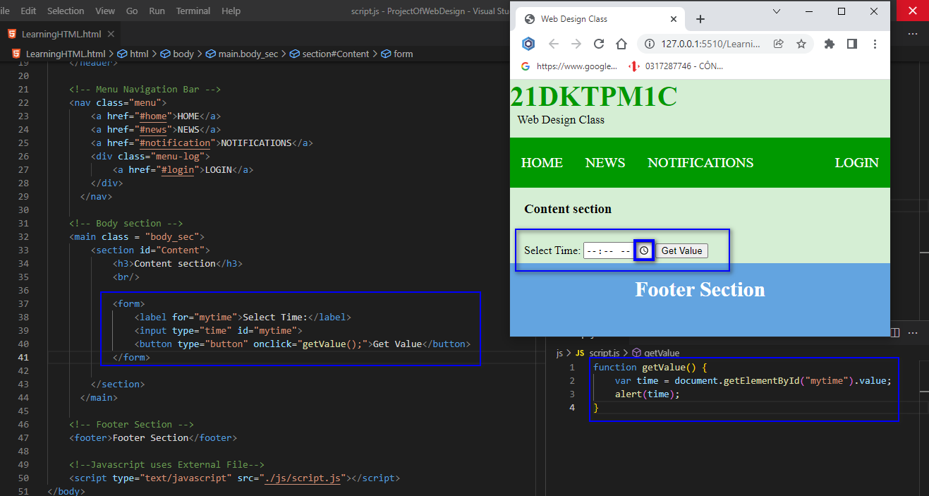

File.html

<!DOCTYPE html>

<html lang="en">

<head>

    <meta charset="UTF-8">

    <meta http-equiv="X-UA-Compatible" content="IE=edge">

    <meta name="viewport" content="width=device-width, initial-scale=1.0">

    <title>Web Design Class</title>

    <link rel="stylesheet" type="text/css" href="./css/style.css">

</head>

<body>

     <!-- Header Section -->

     <header>

        <div class="head1">21DKTPM1C</div>

        <div class="head2">Web Design Class</div>

    </header>

    <!-- Menu Navigation Bar -->

    <nav class="menu">

        <a href="#home">HOME</a>

        <a href="#news">NEWS</a>

        <a href="#notification">NOTIFICATIONS</a>

        <div class="menu-log">

            <a href="#login">LOGIN</a>

        </div>

      </nav>

    <!-- Body section -->

    <main class = "body_sec">

        <section id="Content">

            <h3>Content section</h3>

            <br/>

            <form>

                <label for="mytime">Select Time:</label>

                <input type="time" id="mytime">

                <button type="button" onclick="getValue();">Get Value</button>

            </form>

        </section>

      </main>

    <!-- Footer Section -->

    <footer>Footer Section</footer>

    <!--Javascript uses External File-->

    <script type="text/javascript" src="./js/script.js"></script>

</body>

</html>

File.js

function getValue() {

    var time = document.getElementById("mytime").value;

    alert(time);

}

1. Input Type URL

Minh họa

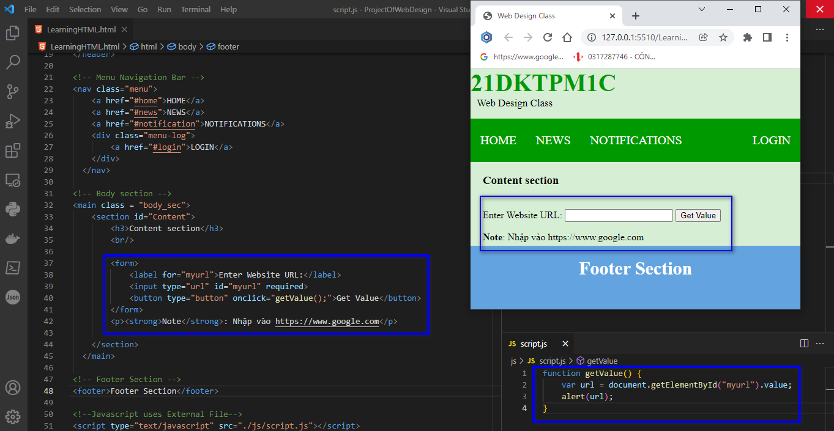

File.html

<!DOCTYPE html>

<html lang="en">

<head>

    <meta charset="UTF-8">

    <meta http-equiv="X-UA-Compatible" content="IE=edge">

    <meta name="viewport" content="width=device-width, initial-scale=1.0">

    <title>Web Design Class</title>

    <link rel="stylesheet" type="text/css" href="./css/style.css">

</head>

<body>

     <!-- Header Section -->

     <header>

        <div class="head1">21DKTPM1C</div>

        <div class="head2">Web Design Class</div>

    </header>

    <!-- Menu Navigation Bar -->

    <nav class="menu">

        <a href="#home">HOME</a>

        <a href="#news">NEWS</a>

        <a href="#notification">NOTIFICATIONS</a>

        <div class="menu-log">

            <a href="#login">LOGIN</a>

        </div>

      </nav>

    <!-- Body section -->

    <main class = "body_sec">

        <section id="Content">

            <h3>Content section</h3>

            <br/>

            <form>

                <label for="myurl">Enter Website URL:</label>

                <input type="url" id="myurl" required>

                <button type="button" onclick="getValue();">Get Value</button>

            </form>

            <p><strong>Note</strong>: Nhập vào https://www.google.com</p>

        </section>

      </main>

    <!-- Footer Section -->

    <footer>Footer Section</footer>

    <!--Javascript uses External File-->

    <script type="text/javascript" src="./js/script.js"></script>

</body>

</html>

File.js

function getValue() {

    var url = document.getElementById("myurl").value;

    alert(url);

}

1. Input Type Week

Minh họa

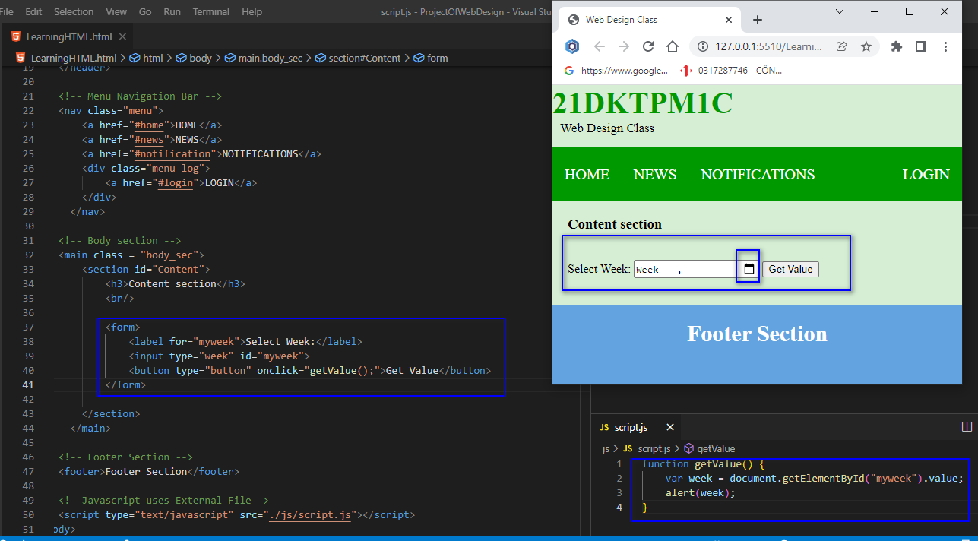

File.html

<!DOCTYPE html>

<html lang="en">

<head>

    <meta charset="UTF-8">

    <meta http-equiv="X-UA-Compatible" content="IE=edge">

    <meta name="viewport" content="width=device-width, initial-scale=1.0">

    <title>Web Design Class</title>

    <link rel="stylesheet" type="text/css" href="./css/style.css">

</head>

<body>

     <!-- Header Section -->

     <header>

        <div class="head1">21DKTPM1C</div>

        <div class="head2">Web Design Class</div>

    </header>

    <!-- Menu Navigation Bar -->

    <nav class="menu">

        <a href="#home">HOME</a>

        <a href="#news">NEWS</a>

        <a href="#notification">NOTIFICATIONS</a>

        <div class="menu-log">

            <a href="#login">LOGIN</a>

        </div>

      </nav>

    <!-- Body section -->

    <main class = "body_sec">

        <section id="Content">

            <h3>Content section</h3>

            <br/>

            <form>

                <label for="myweek">Select Week:</label>

                <input type="week" id="myweek">

                <button type="button" onclick="getValue();">Get Value</button>

            </form>

        </section>

      </main>

    <!-- Footer Section -->

    <footer>Footer Section</footer>

    <!--Javascript uses External File-->

    <script type="text/javascript" src="./js/script.js"></script>

</body>

</html>

File.js

function getValue() {

    var week = document.getElementById("myweek").value;

    alert(week);

}

1. **Xin cảm ơn**